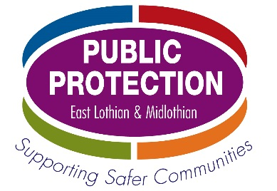

Harmful Sexual Behaviour - Assessment and Interventions (Level 2)

Wednesday 15th May
9.30am – 4.30pm
Pennypit Centre, Prestonpans

Who is this learning for?
The course will support practitioners (including foster carers) who work directly with children and young people and want to learn more about managing the needs of children and young people displaying or experiencing problematic or harmful sexual behaviour (HSB).

Are there any pre-requisites for attending this course?
Applicants must have previously completed Harmful Sexual Behaviour awareness training (Level 1).

How will this training be delivered?
This is a full-day, face-to-face course.

Where will this training be delivered?
This training is at the Pennypit Centre, Training Rooms 1&2, Double Dykes Rope Walk, Prestonpans, EH32 9BN.

What are the learning outcomes?
Upon completion of the course participants will have:
- An understanding of the different assessment frameworks
- An increased understanding of the variants within the context of problematic and harmful sexual behaviour
- An awareness of intervention styles and models to support practitioners working with children or young people displaying problematic or harmful sexual behaviour
- An understanding of psycho-sexual histories and sexual informants
- An understanding of developmentally unexpected sexual interests

Who is facilitating the course?
David Russell is Service Development Lead & Manager, Thriving Survivors. He has extensive experience in providing assessments and interventions for vulnerable children, adolescents and adults within the field of sexual harm and violence. He is an Executive Committee member of NOTA (National Organisation for the Treatment of Abuse) Scotland, co-vice chair of the Community Justice Scotland Network, and an advisory board member of Thriving Survivors, a charity supporting victims of trauma.

How do I apply?
Speak to your line manager about whether this course is suitable for your role and level of experience. Ensure that you are available on the day, and that you have protected time to attend before enrolling. You can then apply by completing the enrolment form overleaf. The closing date for booking on this course is 7th April. Applicants will be notified shortly thereafter if they have been allocated a space on this course.

To book a place please complete the table below and return by e-mail BY NO LATER THAN 7th April (in WORD FORMAT ONLY) to emppo@eastlothian.gov.uk

Harmful Sexual Behaviour - Assessment and Interventions (Level 2)
Wednesday 15th May 9.30am – 4.30pm
Applicant’s full name

Job Title

Team

Organisation/Agency Name

Applicant’s e-mail address

Line Manager’s full name

Line Manager’s e-mail address

In submitting this form, I confirm that my manager has granted me protected learning time to attend this course. I also agree to complete an on-line evaluation of the training after I have attended.

Electronic Signature:

